**Observations from the data set:**

1. Creating geom_col on the basis of age:

g<-ggplot(Satisfaction5,aes(x=Age,y=count_5))+geom_col()

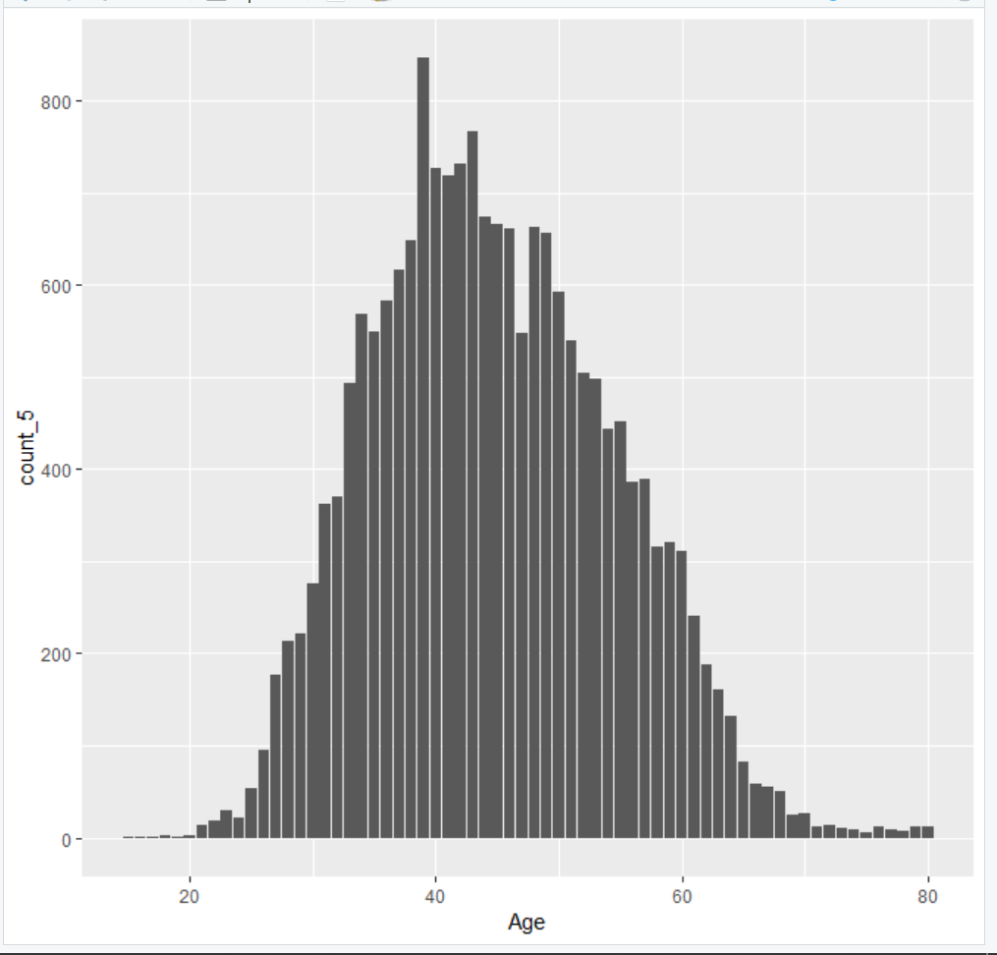

This is a bell-shaped curve implying that maximum people fall under the age group of 30 to 50. We can collect data related to them to analyze how their customer satisfaction can be improved.

1. g<-ggplot(Satisfaction5,aes(x=Partner.Name,y=count_5))+geom_col()

g<-g+theme(axis.text.x=element_text(angle = 90,hjust=1))

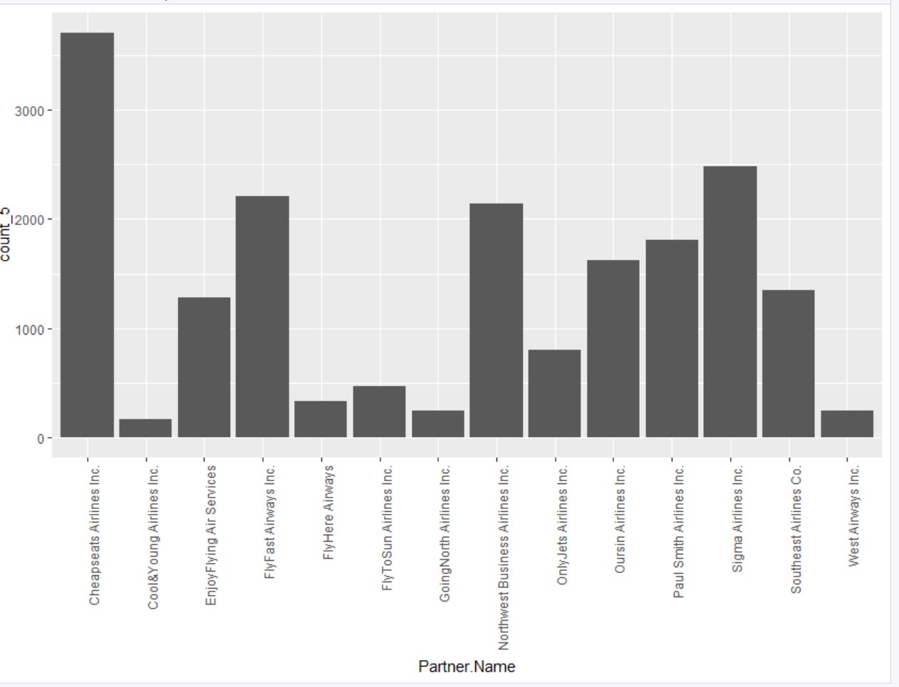

This is a bar-plot implying that cheatseats airlines has the highest customer count while Cool&YoungAirlines Inc. has the lowest customer count. We can collect data related to them to analyze how their customer satisfaction can be improved.

3.g<-ggplot(Satisfaction5,aes(x=Origin.State,y=count_5))+geom_col()

g<-g+theme(axis.text.x=element_text(angle = 90,hjust=1))

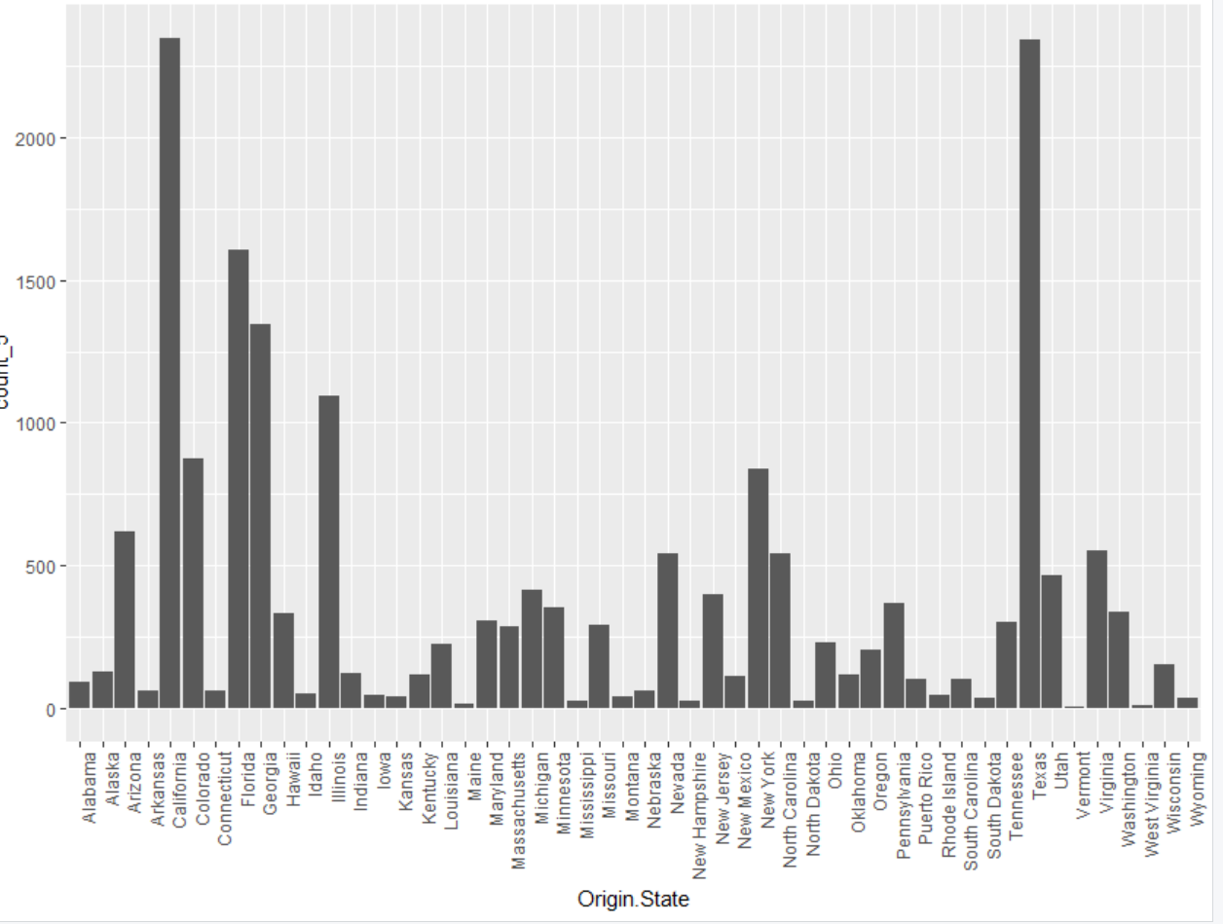

This is a bar-plot implying that California and Texas have the maximum count from all the origin states and Utah has lowest. We can collect data related to them to analyze how their customer satisfaction can be improved.

4.

* 1. What is **working well** within the project group?

We have successfully conducted our team meetings for the first week and there’s clear and good communication amongst all team members. We learnt to use Trello and analyzed the dataset and also made certain observations from it

* 1. What is **not working well** within the project group?

Everything has been going well. Sometimes it does become a little difficult to schedule the team meetings as everyone has different schedules, but we have successfully managed to meet this week and will look forward doing the same regularly.

* 1. Any specific **questions** the group has related to the project?

Do we need to analyze the complete dataset or do we need to take a more specific sub dataset to get more accurate results.

* 1. Any specific **issues** the group is facing.

None as of now.

* 1. Provide a **link** to your trello board.

https://trello.com/b/t5xGUna0/project-update1